Architecture Overview
This project follows a simple architecture:
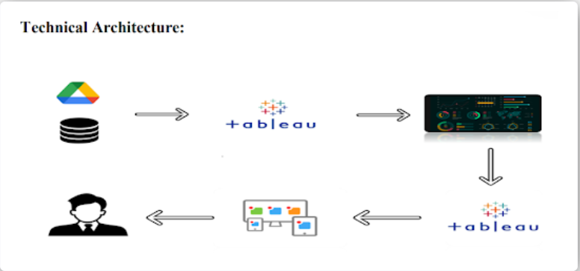
Dataset (CSV)
⬇
Tableau Desktop
- Data preparation
- Visualizations
- Dashboard
- Story
⬇
Tableau Public (Publishing)
⬇
Flask Web Application
- Dashboard HTML Embed
- Story HTML Embed
⬇
End Users (Retail Analysts / Managers)

Components
- Data Source
  - Kaggle dataset in CSV format
- Visualization Layer
  - Tableau Desktop
- Publishing Layer
  - Tableau Public cloud platform
- Web Integration Layer
  - Flask server
  - HTML pages (Dashboard + Story)
- User Interface
  - Home page navigation
  - Dashboard page
  - Story page

